A Child Needs its Space

Source Code:

#include <time.h>
#include <sys/types.h>
#include <unistd.h>
#include <sys/file.h>
#include <string.h>
#include <stdio.h>
#include <stdlib.h>

int main()
{
double x, y, z;
double cx, cy, cz;
int i, j, k = 0;
FILE *ifp;
int numbersArray[96];
int sum = 0;
int count = 0;
pid_t id = 0;
// clock function
x = clock(); /*Strcat the clock*/

if ((id = fork()) == 0) /* child executes background job now */
{
cx = clock();
ifp = fopen("numbers.dat", "r");
if (!ifp)
{
printf("\n\tcannot open input file\n\n");
return (1);
}
else
{
int size = sizeof(numbersArray) / sizeof(int);
for (i = 1; i <= size; i++)
{
fscanf(ifp, "%d", &numbersArray[i]);
for (j = i + 1; j < size; j++)
{
fscanf(ifp, "%d", &numbersArray[j]);
if (i < j)
{
for (k = j + 1; k < size; k++)
{
if (j < k)
{
fscanf(ifp, "%d", &numbersArray[k]);
sum = numbersArray[i] + numbersArray[j] + numbersArray[k];
if (sum == 100)
{
printf("\nThe Sum is: %d + %d +%d = %d\n", numbersArray[i], numbersArray[j], numbersArray[k], sum);
}
}
}
}
}
// fclose(ifp);
}
cy = clock();
cz = (cy - cx) / CLOCKS_PER_SEC;
printf("\nThe time child took is: %lf seconds \n\n", cz);
_exit(1); /* End the process */
}
}
else if (id < 0)
{
fprintf(stderr, "fork failed\n");
perror("background:");
}

wait(NULL);
y = clock();
z = (y - x) / CLOCKS_PER_SEC;

printf("\nThe time parent took is: %lf seconds \n\n", z);

}

Output:

Different sizes file:

For numbers of 100:

int numbersArray[96];

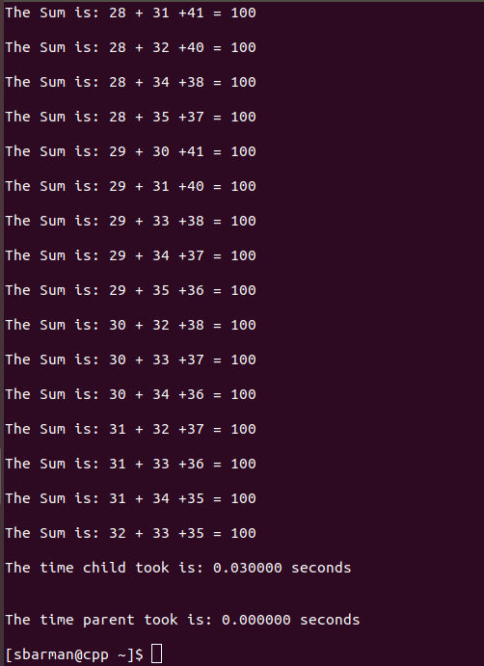

For numbers of 300:

int numbersArray[296];

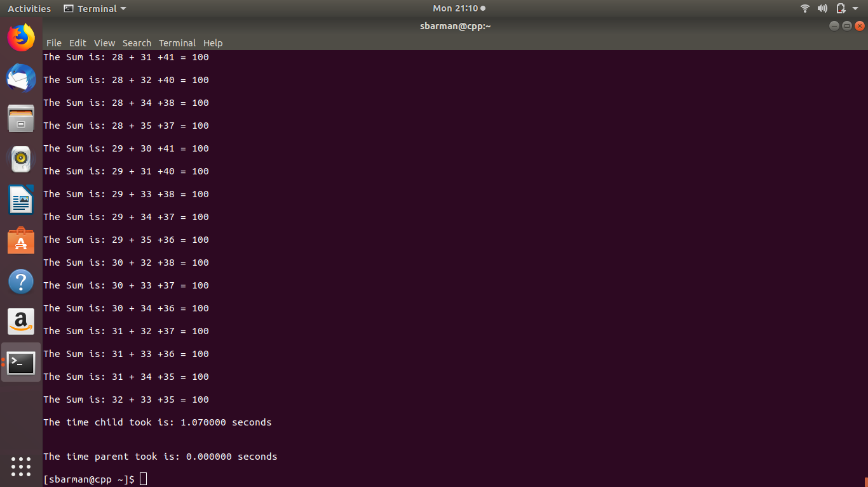

For numbers of 500:

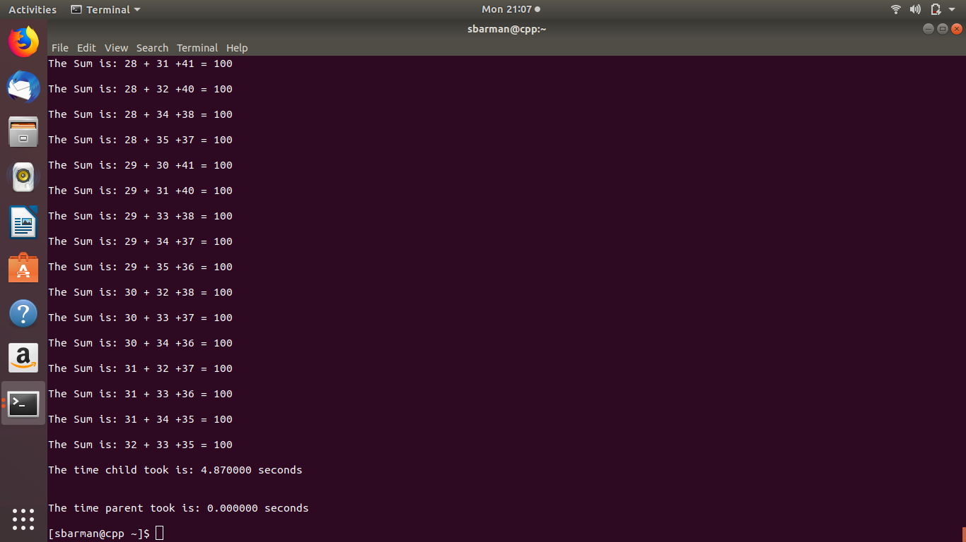
int numbersArray[496];

Big O notation:
When we develop an algorithm to solve a problem, we want to know about its growth rate (complexity) when the problem size becomes extremely large. Among of the algorithms for solving a problem, based on the observed complexity, we can select a proper algorithm which requires less time or produces faster response for a problem based on the size and characteristics of the input.

I need to use some concepts from Mathematics like asymptotic upper bound, lower bound. By using them, we can find a simpler asymptotic function g(n) that acts as an upper limit or lower limit of the function T(n) we want to evaluate. We will discuss about the upper bound for Big O analysis.
In mathematics, a function g(n)g(n) is the upper bound of a function f(n)f(n) is defined at: f(n)=O(g(n)f(n)=O(g(n) if there exists some constant c such that f(n)f(n) is always ≤c⋅g(n) c·g(n), for large enough nn (i.e. , n≥n0n≥n0 for some constantn0n0).
The following graph visualizes the definition off (n) = O(g(n))f(n)=O(g(n))

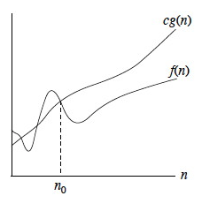

(Source: Growth of Functions and Asymptotic Concepts)
I use Big-O notation to relatively represent the complexity of an algorithm. Big-O notation is a simplified function that acts as an asymptotic upper bound of the complexity function of the algorithm. By using the simplified function.

Result in the Program: Below are the test results of the execution of the program with the different files containing 100,300,500 numbers.
Numbers file | Time taken (child) | Time taken (parent)
100(numbersArray[96]) | 0.030000 | 0.000000
300(numbersArray[296]) | 1.070000 | 0.000000
500(numbersArray[496]) | 4.870000 | 0.000000

For child:
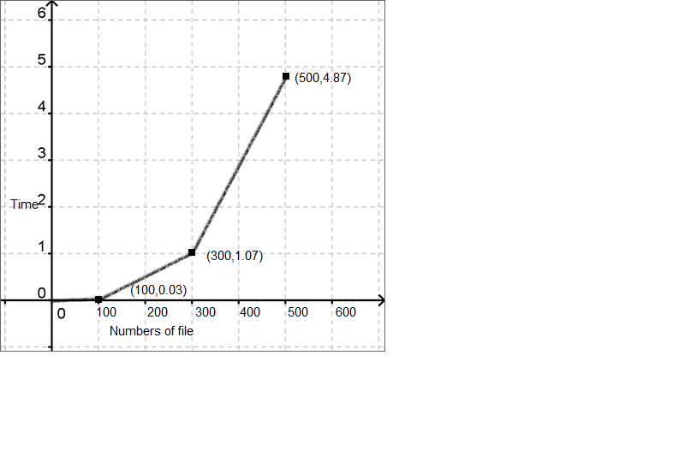
The graph of sum
How to compile:

gcc parentchild.c -o parentchild

This will generate the executable main and you can run it using

./parentchild

The data structure I have used in the program is array of long int type, the limitation on input is the file size cannot exceed more than 100,000 as it is the size defined in the program. The output has no certain limitations as it shows when the sum of two numbers match the pre-determined random values generated within 10000.

Upon starting the program initializes the variables including the clock and opens the file in the read mode and check if it is opened or not. After that the file descriptor is passed to the read File function, the declaration is as follows.

//* fscanf(ifp, "%d", &numbersArray[i]);
fscanf(ifp, "%d", &numbersArray[j]);
fscanf(ifp, "%d", &numbersArray[k]);*//

First reads the inputs file line by line and store the numbers on each line in the data structure and upon the end it returns the data structure where it is stored in a pointer declared in the main function.

This array of type long int is then passed to the three Sum function , the definition is as follows.
//* if (j < k)
{
fscanf(ifp, "%d", &numbersArray[k]);
sum = numbersArray[i] + numbersArray[j] + numbersArray[k];
if (sum == 100)
{
printf("\nThe Sum is: %d + %d +%d = %d\n", numbersArray[i], numbersArray[j], numbersArray[k], sum);
}
}*//

This function has a nested loop which has a complexity of O(n^3) and it sums the first with the 2nd and the 3rd, then the 1st with the 2nd, then the 4th, then the 1st with the 2nd, then the 5th, and so on. Then increment the middle loop and add the 1st with the 3rd, then the 4th, and so on. The program the spawns a child process from the parent process. In the child process implement the Three Sum algorithm. As we know, the Three Sum algorithm has O(n^3) order and hence takes a long time to complete. I use the especially for larger files (100, 300 and 500). Different files I use in program so it’s come different time.

I Use the clock() to compute the time it takes to run the program. Start the clock at the beginning of the program and end it at the end of the program, then compute the execution time.

//* x = clock(); /*Strcat the clock*/

if ((id = fork()) == 0) /* child executes background job now */
{
cx = clock();
ifp = fopen("numbers.dat", "r");
if (!ifp)
{
printf("\n\tcannot open input file\n\n");
return (1);
}*//

This give a surprising result, especially for larger numbers as I wait for the program to execute. Then begin the clock inside (at the beginning) the child process and end it at the end of the child process. Compute the execution time of the child process and note it and the time of the parent process and note that. The wait( ) function (so the parent waits for the child to complete) and without the wait( ) function.

//* cy = clock();
cz = (cy - cx) / CLOCKS_PER_SEC;
printf("\nThe time child took is: %lf seconds \n\n", cz);
_exit(1); /* End the process */
}
}
else if (id < 0)
{
fprintf(stderr, "fork failed\n");
perror("background:");
}

wait(NULL); //* I use wait() function*//
y = clock();
z = (y - x) / CLOCKS_PER_SEC;

printf("\nThe time parent took is: %lf seconds \n\n", z);

}*//

Fork system call use for creates a new process, which is called child process, which runs concurrently with process (which process called system call fork) and this process is called parent process. After a new child process created, both processes will execute the next instruction following the fork() system call. A child process uses the same program counter, same CPU registers, and same open files which use in the parent process. I use the fork system because I take two clock function (parent & child).

When file size is decreasing the numbers of hits are decreasing which is resulting in the time taking to calculate, this result can vary and depends on the pre-determined numbers and on the processing power of computer/server.

